**Data Camp Python Class**

**Class 1:**

Pre-class study preparation (optional):

Jupyter Notebook: <https://jupyter-notebook.readthedocs.io/en/stable/>

Class: <https://docs.python.org/3.6/tutorial/classes.html>

Jupyter notes for these classes: <https://github.com/PDmitriy/dscamp_public/tree/master/Python%20Programming>

**Variable:**

* int and its operations (+, -, * , /，//, %)
* float and its operations (+, -, * , /)
* bool (and/or/not)
* practice:

A+B problem: <https://www.lintcode.com/problem/a-b-problem/>

**Function**

* why?: code reuse and readability
* def and parameter of function

**Control Flow**

* if/elif/else
* for loop, while; break, continue (optional)
* practice:

Max of 3 Numbers– <http://www.lintcode.com/en/problem/max-of-3-numbers/>

Trailing Zeros (optional) <https://www.lintcode.com/problem/2/>

**Object Oriented Design (a brief introduction)**

* class
* _init_()/self

**Python packages and its import**

Instructors need to briefly describe the use of each package.

* numpy
* Pandas
* sklearn
* keras/tensorflow

Practice:

(1) Download stock prices from yahoo finance, for example:

<https://finance.yahoo.com/quote/WFC/history?period1=1557764759&period2=1589387159&interval=1d&filter=history&frequency=1d>

<https://finance.yahoo.com/quote/GE/history?p=GE>

<https://finance.yahoo.com/quote/AAPL/history?period1=1557764937&period2=1589387337&interval=1d&filter=history&frequency=1d>

(2) import numpy, read a data set from csv

(3) visualized the data in python

**Class 2:**

Pre-class study preparation (optional):

List:<https://docs.python.org/3.6/tutorial/introduction.html#lists>

Tuples:<https://docs.python.org/3.6/tutorial/datastructures.html#tuples-and-sequences>

String:<https://docs.python.org/3.6/tutorial/introduction.html#strings>

Built-in Types:[https://docs.python.org/3.6/library/stdtypes.html#sequence-types-str-unicode-list](https://docs.python.org/3.6/library/stdtypes.html#sequence-types-str-unicode-list-tuple-bytearray-buffer-xrange)

**List:**

* Create: +, append, insert, extend
* Read: iteration, slice, in, index, count
* Delete: pop, remove, del
* Update/len/sort/reverse
* Tuple (optional)
* practice:

Swap two integers in an array using function – <http://www.lintcode.com/en/problem/swap-two-integers-in-array/>

remove element (optional): <https://www.lintcode.com/problem/remove-element/description>

**String**

* Immutable
* Character: ord() and chr()
* ASCII and Unicode
* operations: +,*,iteration, slice, find, replace, len
* practice:

Lowercase to Uppercase <https://www.lintcode.com/problem/lowercase-to-uppercase/description>

**Dictionary**

* Create
* Read: find, iteration, in, get, keys, values, items
* Update
* Delete: pop, del
* Len
* Practice: build a dictionary

**Final Project (Optional)**

Leap Year - <https://www.lintcode.com/problem/leap-year/>

Lintcode interface:

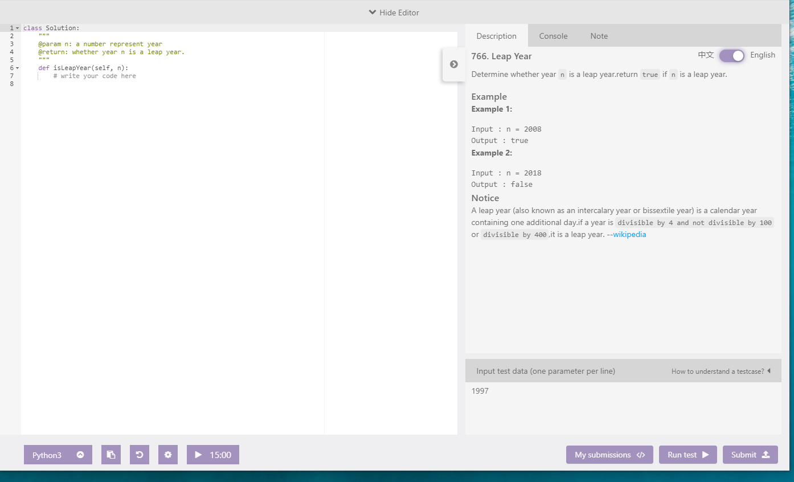

Google Colab

(1) Import the code form GitHub

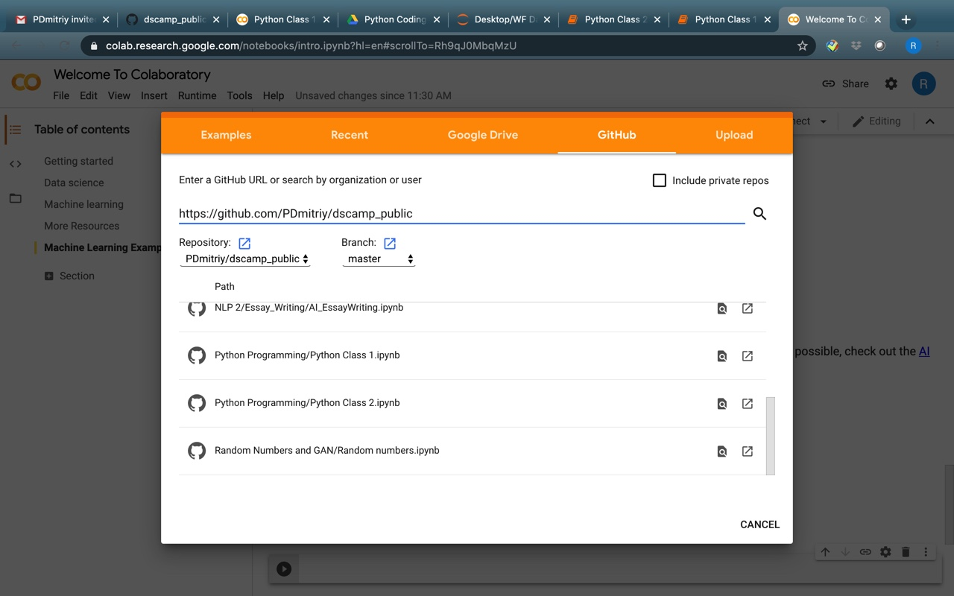

(2) Run the code in Google Colab.

